1.1P: Preparing for OOP – Answer Sheet

# Introduction

This paper ’s answer sheet serves two purposes:

1. It serves as a revision for you of your previous learnings; and
2. It establishes a baseline understanding of your knowledge in key Computer Science topics.

As such this paper is divided into the following areas of knowledge:

1. Your experience with UNIX/DOS console commands;
2. Your ability to differentiate between data types (e.g. text) and information categories (e.g. title);
3. Your experience with compiler parsing and evaluation of expressions according to rules of precedence (e.g. BODMAS, also known as GEMS or PEMDAS);
4. Your understanding of Computer Science concepts and various compiler constructs such as blocks and scope;
5. Finally taking three steps, we want you to develop a program as follows:
   1. starting with a simple function: you provide the pure logic and calculations, no input, nor output;
   2. Then, in the second step, you write the main line code that invokes that simple function. Your main line code will provide the necessary data, and then you will print out the result of the function’s calculation.
   3. Finally we want you to add business logic to the main line program’s code; that business logic will interpret the results of the function, and inform your user with information about the results.

## Section A: Console commands

1. Explain the following terminal instructions:

1. cd: Change Directory
2. pwd: Print Working Directory
3. mkdir: Make Directory
4. cat: Print out content of a file
5. ls: List down all the item in the directory

## Section B: Data types and Information categories

1. Consider the following categories of information, and suggest the most appropriate data type to store and represent each kind of information:

|  |  |
| --- | --- |
| **Information Category** | **Suggested Data Type** |
| A person’s family name | String |
| A person’s age in years | Integer |
| A person's weight in Kilograms | Float |
| A telephone number | String |
| A temperature on the Kelvin scale | Float |
| The average age of a group of children | Float |
| Whether the student passed this task | Boolean |

1. Aside from the examples already provided above, please come up with your own examples of information that could be stored as:

|  |  |
| --- | --- |
| **Data Type** | **Suggested Information Category** |
| String | Supermarket name |
| Integer | Number of supermarkets |
| Float | Distance from your home to the nearest supermarket |
| Boolean | Is 2.5 an integer? |

**Section C: Compiler evaluation of expressions**

1. Fill out the **last** two columns of the following table based on the expression and values we have supplied.
2. Evaluate the value of each expression under column 1, given its formula, values, and variables; use the given values (column 2) of any variable(s) in the expression.
3. Identify the value of the results (column 3), and the data type the result is most likely to be (column 4) in a complier “friendly” form (e.g. Float):

|  |  |  |  |
| --- | --- | --- | --- |
| **Expression** | **Given** | **Result** | **Data Type** |
| 76 |  | 76 | Integer |
| True |  | True | Boolean |
| a | a = 3.1415927 | 3.1415927 | Float |
| 1 + 2 * 3 + 4 |  | 11 | Integer |
| a and False | a = True | False | Boolean |
| a or False | a = True | True | Boolean |
| a + b | a = 1  b = 3 | 4 | Integer |
| 3 * a | a = 5 | 15 | Integer |
| a * 2 + b | 1. = 2.5 2. = 3 | 8.0 | Float |
| a + 2 * b | 1. = 2.5 2. = 3 | 8.5 | Float |
| (a + b) * c | a = 2  b = 4  c = 6 | 36 | Integer |
| “Fred” + “ Astair” |  | Fred Astair | String |
| a + “ Rogers” | a = “Ginger” | Ginger Rogers | String |

**Section D: Compiler Constructs and CS Concepts:**

1. Using some code as an example, please explain the difference between **declaring** and **initializing** a variable.

The difference between the two is: Declaring is used to specify the variables datatype. While initializing is used to assign value to the variable and you can do it with declaration or in a separate line.

*Paste your example code below:*

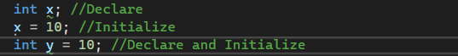

1. Explain the term **parameter**. Write some **code** that demonstrates a simple of use of a parameter. You should show a procedure or function that uses a parameter, and how you would call that procedure or function.

A parameter is a variable and are used in a function or procedure to do a task that will relate to a data provided as input. A parameter will act as an Argument and it will be passed to the function when it is called.

*Paste your example code below:*

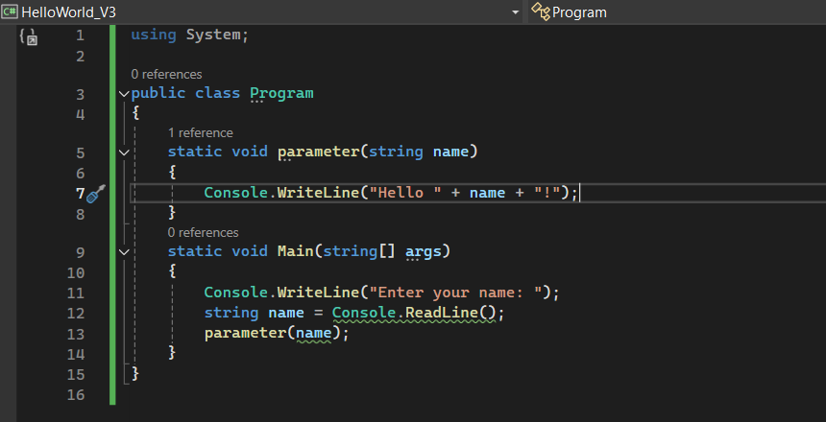

1. Using an **coding example**, describe the term **scope** as it is used in procedural programming (not in business nor project management). Make sure you explain the differences of as many kinds of scope that you can identify (at least two, and up to five).

Scope is a term to define where variables and functions can be used, scope helps organize and manage the availabilities of variables which will help avoiding unintended error.

*Paste your example code below:*

Local Scope:

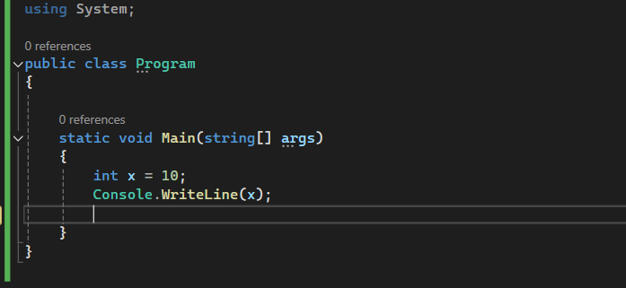

Global Scope:

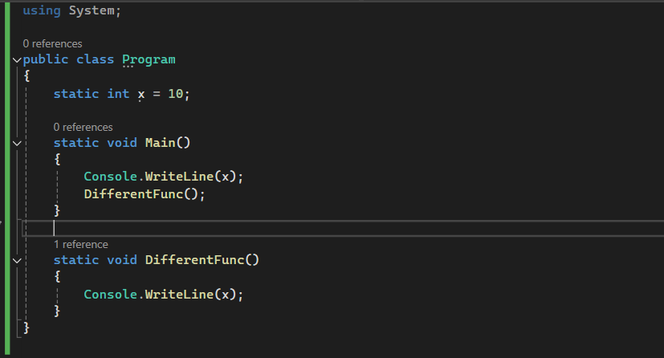

## Section E: Implementing Algorithms, Data Handling, and Informing Results - Personalized Requirements

**STEP 1:**

1. In a procedural style, in any language you prefer, write a function called Average, which accepts an array of integers, and returns the average of those integers.
2. **Do not use any libraries for calculating the average**: we want to see your understanding of algorithms.
3. You must demonstrate appropriate use of parameters, returning and assigning values, and the use of loop(s). **Note — just write the function at this point.** In the next step we will ask you to ***invoke the function.***
4. You should **not** have a complete program, **nor** even code that outputs anything at this stage. This is a **function**; and input/output and any business logic processing is the responsibility of the (main line) calling code.

*Paste your example function code below:*

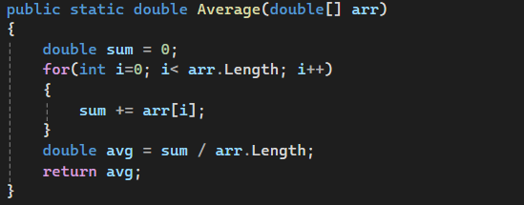

**STEP 2:**

1. Using the same preferred language, write the main line calling code you would need to (a) marshal the data, (b) invoke the function, (c) print out the result, and (d) **print out your student name and student Id**
2. We do **not** require you to provide any input processing logic; you simply have provide the inline instantiate of a collection of data values (provided below) for the function to calculate the average of that data set.

a. Sample data values

2.5, -1.4, -7.2, -11.7, -13.5, -13.5, -14.9, -15.2, -14.0, -9.7, -2.6, 2.1 7. Note: your should have made **no changes** to your function.

*Paste all of your example code below:*

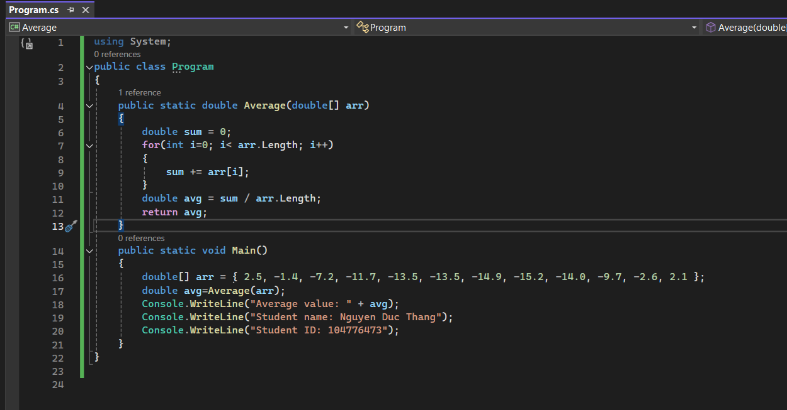

*Paste your example code’s output here:*

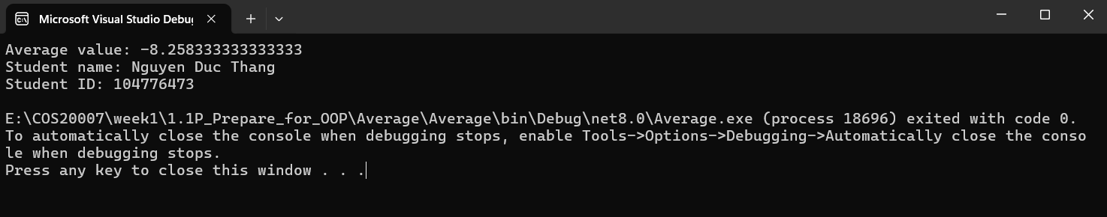

1. Using the same preferred language, add to your existing main line code above, the following business logic code for interpreting the result of the function’s calculations.
2. Print the message “Multiple digits” if the average is above or equal to 10. Otherwise, print the message “Single digits”.

10.And then, if the average is negative, add an additional line of output stating “Average value negative”.

11.Finally, if the last digit of the average is larger than the last digit of your Student ID, please print the message "**Larger than my last digit**". Otherwise, please print the correct message, either "**Equal to my last digit**" or "**Smaller than my last digit**".

12.Note, you should not have made any changes to your implemented function13.Provide evidence of your program running, i.e. the code, its environment, and its run time outputs.

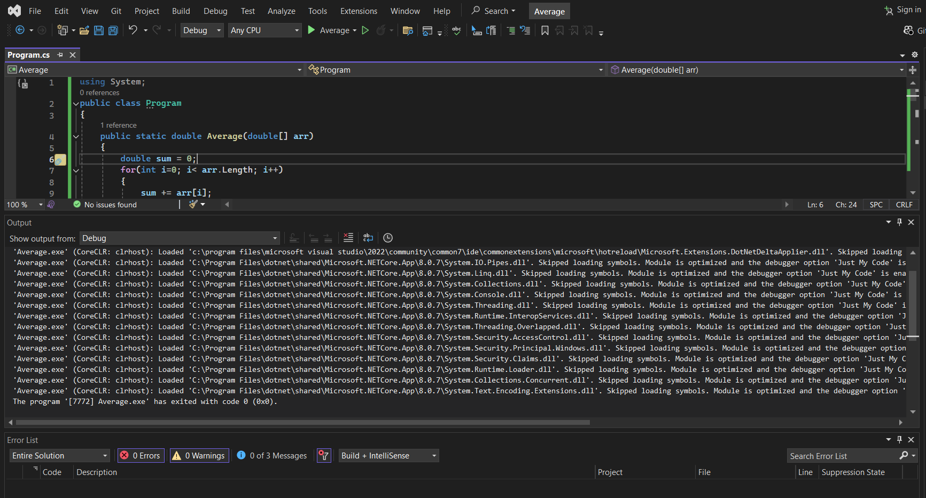

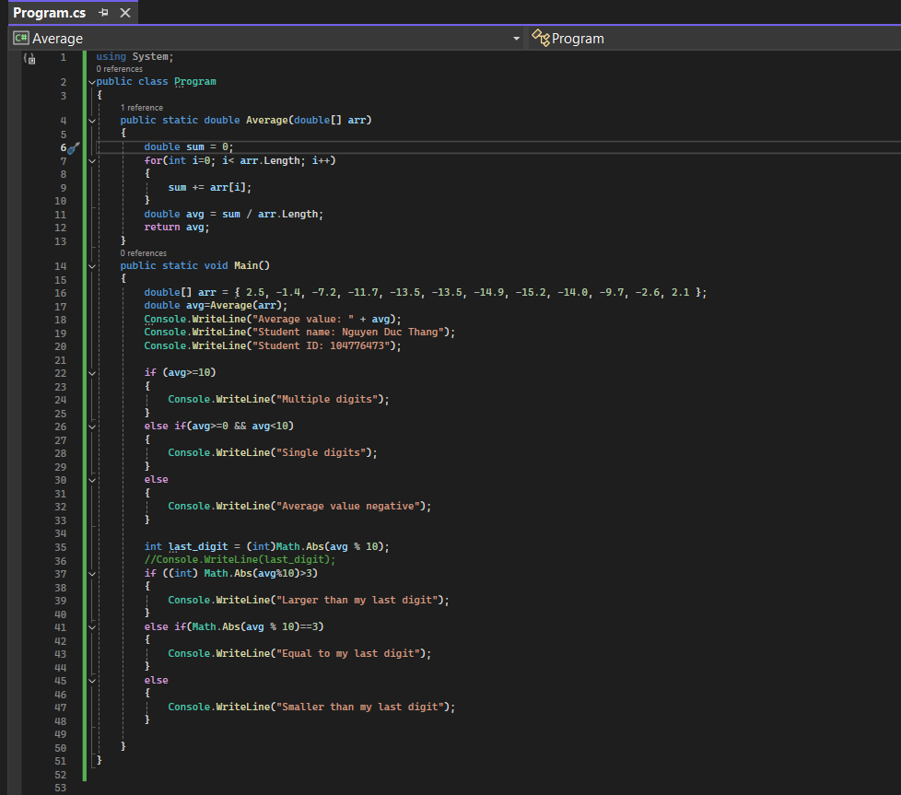

*Paste your example code’s output here:*

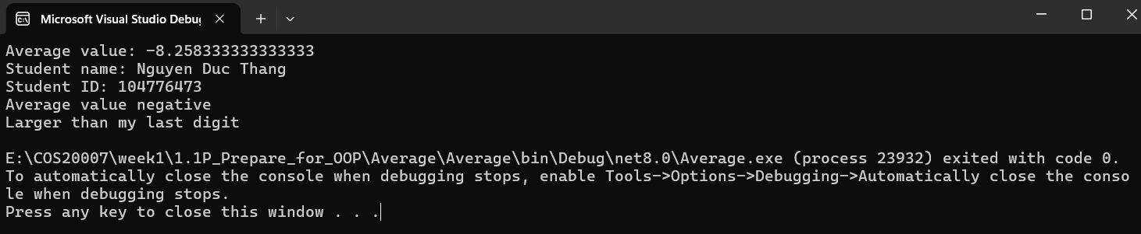

*Finally on a new page paste a SINGLE screenshot of your program (main line and function) running with its outputs here:*

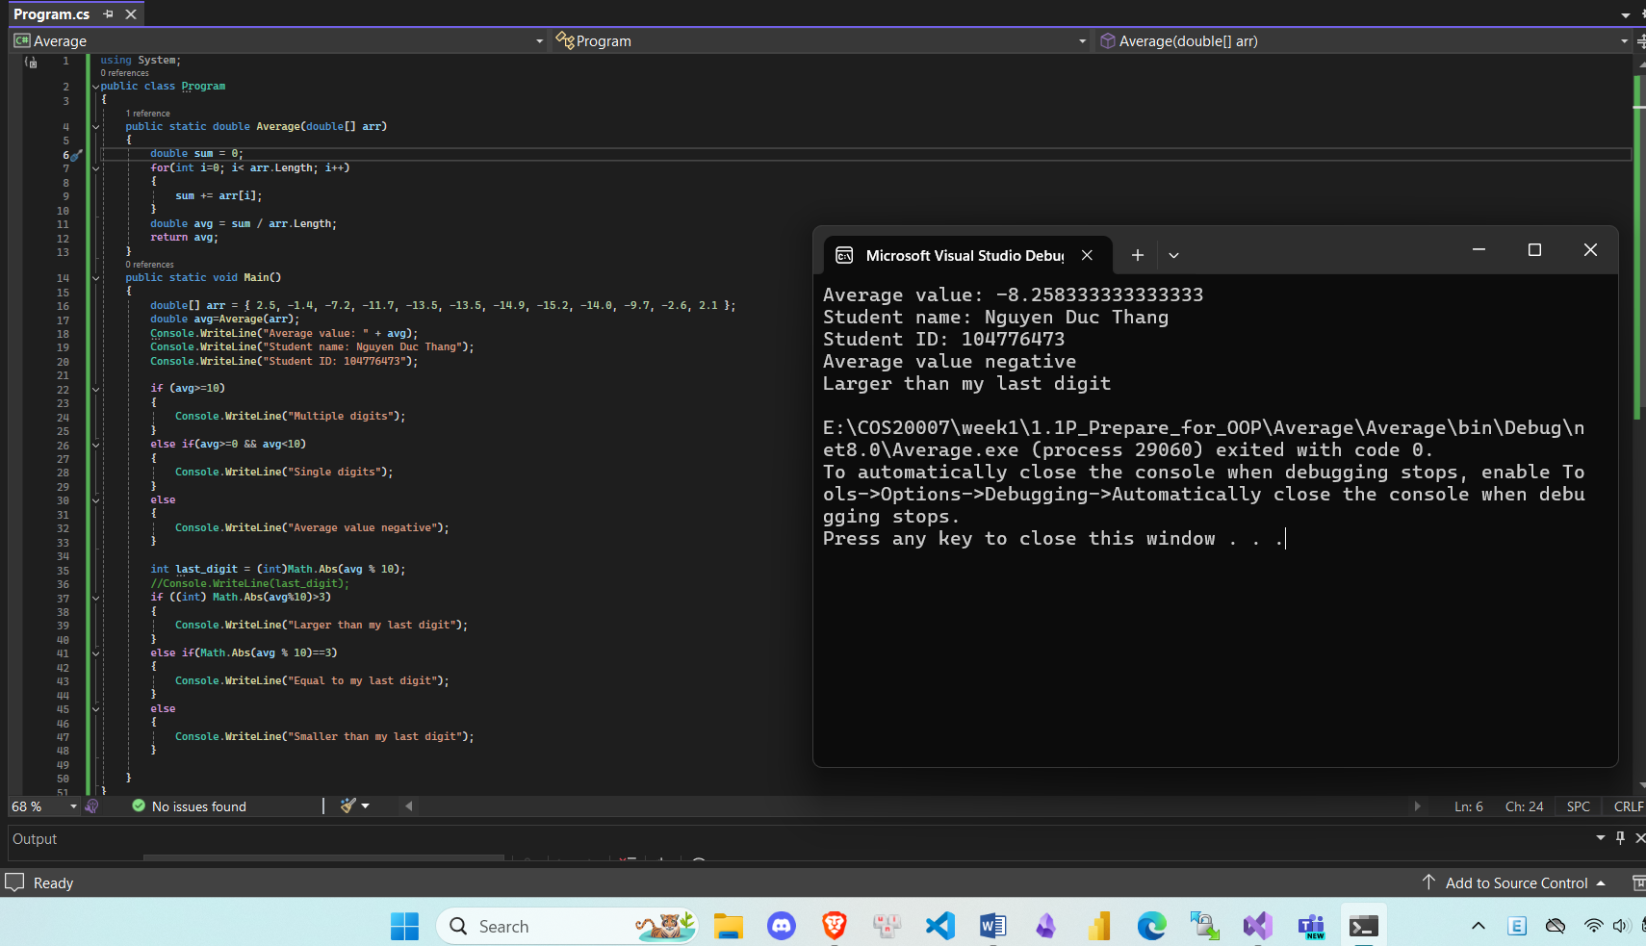

# End of Task

**Please render your paper as a PDF and submit via CANVAS.**